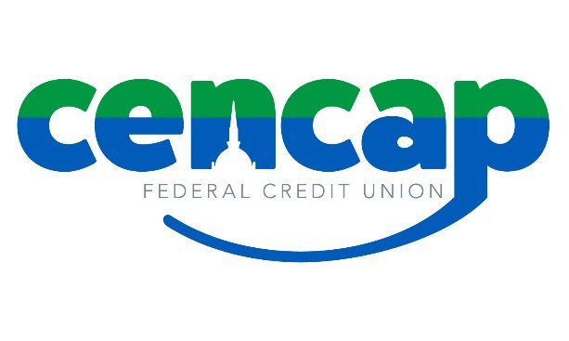

Scholarship Application 2018
To qualify for a scholarship, the student/applicant must be a Cencap member in good standing. The student must be in their senior year of high school and planning to study at an institution for higher learning in the fall of 2018. Student must show academic excellence and community service. In addition to completing this application, two letters of recommendation from non-family members and a 500 word, typed essay outlining why you deserve this scholarship and your commitment to completing your education.

Employee, Board and Supervisory Committee family members are not eligible.
Application must be typed, completed and received by March 23, 2018 to:

Cencap Federal Credit Union
443 Franklin Avenue
Hartford, CT 06114
OR Email to info@cencap.com

First and Last Name
Email

Street Address

City

State

High School Currently Attending

Anticipated Graduation Date

Cumulative GPA

Fall of 2018:

Planned Program of Study

College or University

List honors and awards:

List extracurricular activities, volunteering and work experience:

Reference
Name
Address
Phone
Relation to you:
Reference
Name
Address
Phone
Relation to you:

Statement of Accuracy
I hereby affirm that all of the above information provided by me is true and correct to the best of my knowledge. I also consent that my picture may be taken and used for any purpose to promote Cencap Federal Credit Union.

Scholarship winners will be notified by April recipients will be notified by April 16, 2018 and are expected to be present at our Annual Meeting, April 30, 2018 for the scholarship acceptance.

Signature Date

For questions, please contact 860.757.0594 or email info@cencap.com

